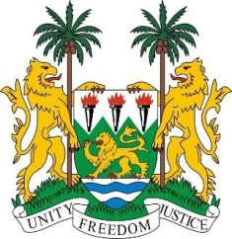
SIERRA LEONE
24th Session of the UPR

UPR of NIGER

18 January 2016

Mr President,

Sierra Leone warmly welcomes the delegation of the Niger and thanks them for their national report.

Since its last review cycle, the Government of Niger has put in place new polices and strategies for the promotion and protection of human rights nationally, some of which include various measures and laws aimed at comprehensively combatting trafficking in persons.

In recent years, Niger is one of the countries to have been targeted by the terrorist group, Boko Haram, and the government should be commended for their commitment to tackling this threat in a holistic manner, and by working with regional partners.

Furthermore, my delegation notes that Niger is considering establishing a National Policy on Justice and Human Rights, as well as a Ten-year Action Plan. Sierra Leone would therefore encourage efforts aimed at their implementation.

My delegation would also encourage Niger to put in place policies which would ensure a fuller participation of women in decision-making at all levels of government, as well implementing more comprehensive preventative strategies to combat gender-based violence.

Recommendations:

- Remove reservations to core human rights instruments including the CAT, ICERD, CEDAW and ICRMW.
- Establish normative frameworks to help domesticate the human rights instruments it has ratified.
- Promote awareness-raising campaigns and adaptive policies aimed at eliminating child, early and forced marriage.
- Submit overdue reports to the relevant UN treaty bodies.

To conclude, Sierra Leone wishes Niger a successful review.

Thank you, Mr President.

